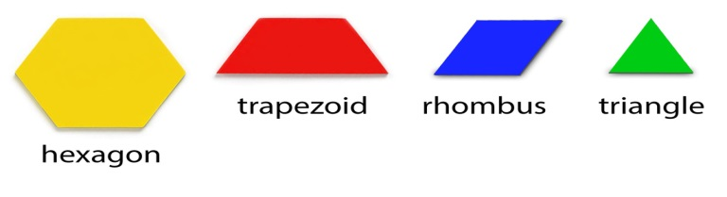
Gr. 4 Fractions Diagnostic

Use the yellow hexagon as the whole. Trace each shape on grid paper. Beside each write the different fractions of the whole that each part represents. Show other fractions that can be made using the different pieces. What do the numerator and denominator of each fraction tell you?

Gr. 4 Fractions Diagnostic

Use the yellow hexagon as the whole. Trace each shape on grid paper. Beside each write the different fractions of the whole that each part represents. Show other fractions that can be made using the different pieces. What do the numerator and denominator of each fraction tell you?

Assessment For Learning Gr. 4 Fractions
Expectation: represents fractions using concrete materials, and fractional notation and explain the meaning of denominator and numerator.
Got It - √+ General Knowledge- √ Some Idea- √- Needs Explicit Teaching- T
Student Name | Accurately represents a variety of fractions with concrete materials | Accurately records the fractional notation for representations | Clearly and completely explains the meaning of denominator and numerator

