[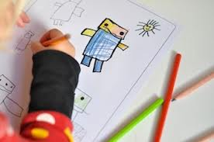](http://www.google.ca/imgres?start=133&hl=en&biw=1280&bih=930&tbm=isch&tbnid=4tAY-OGmODsitM:&imgrefurl=http://www.thecraftycrow.net/bookmaking/&docid=2qzZ6dIGWQmJSM&imgurl=http://belladia.typepad.com/.a/6a00d8341cc08553ef017c31679d66970b-pi&w=350&h=232&ei=Hq4EU9K8KoTsyQGpjIG4Cg&zoom=1&ved=0CJsBEIQcMDI4ZA&iact=rc&dur=634&page=6&ndsp=30)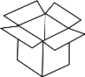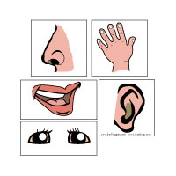

**Give One Get One**

1. When you hear the word ‘___________’ what do you think about or picture?
2. Fill in the top two (2) boxes with a picture or a word that shows your idea.
3. Talk to your classmates about your ideas. Take an idea from each classmate to fill in the four (4) other boxes.
4. Together we will fill in the bottom box.







|  |  |
| --- | --- |
|  |  |
|  |  |
|  |  |
|  | |

**www.etfoassessment.ca**